ES PROJECT
Gas Leakage Detection System using ESP32 and Blynk
NAME: Vansh bansal, Himanshu Tambuskar , Chinmay patil , Shekhar bhojane.
COURSE: B.Tech(IT), A1

Aim
The aim of this project is to design and implement an IoT-based Gas Leakage Detection System that can sense the presence of harmful gases in the environment and alert the user immediately through an LED, buzzer, LCD display, and Blynk mobile application. The project leverages ESP32’s Wi-Fi capabilities to connect to the Blynk IoT platform for real-time monitoring and notifications.

Introduction
Gas leakage is a common hazard in households and industries that can lead to serious accidents, explosions, or health issues. Hence, an early detection and alert system is vital for safety. This project utilizes the MQ gas sensor, ESP32 microcontroller, and Blynk IoT platform to detect gas concentration and notify users remotely. The LCD displays the gas concentration in parts per million (ppm), while the LED and buzzer act as local indicators. The system is connected to Wi-Fi, and real-time data is sent to the Blynk dashboard and mobile app.

Components Used
- ESP32 Microcontroller: Serves as the main processing and communication unit. It reads sensor data and connects to Wi-Fi to send readings to the Blynk cloud.
- MQ Gas Sensor: Detects the presence and concentration of gases such as LPG, methane, and propane.
- LCD Display (16x2 with I2C): Displays real-time gas concentration and alert messages.
- LED: Indicates the gas leak condition locally.
- Buzzer: Produces an audible alert in case of gas leakage.
- Blynk IoT Platform: Used to remotely monitor gas concentration and receive alerts on a smartphone.
- Wi-Fi Connection: Provides internet connectivity for sending sensor readings to the Blynk cloud.

Circuit Diagram

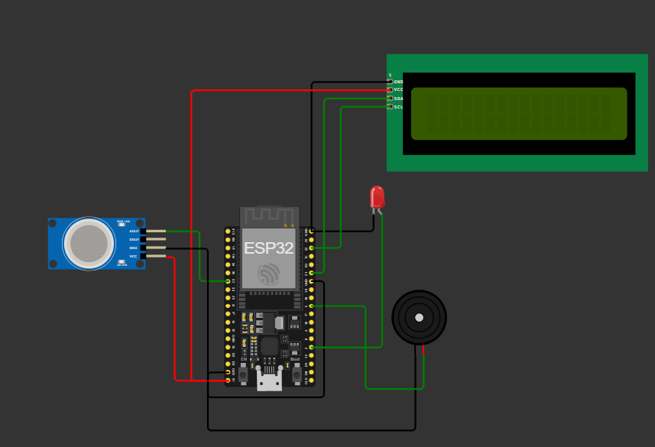

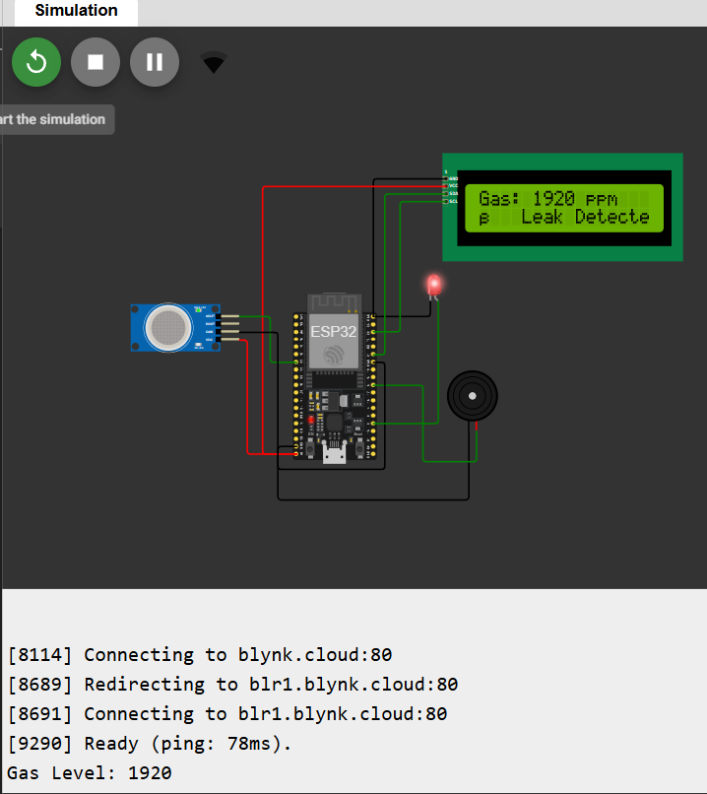

Working Principle
The MQ sensor continuously measures gas concentration levels. The ESP32 reads the analog values from the sensor and converts them to ppm. If the gas concentration exceeds 600 ppm, the system triggers a warning: the LED glows, the buzzer sounds, and an alert message is displayed on the LCD. Simultaneously, the data is sent to the Blynk cloud using Wi-Fi, where it can be viewed in real-time on the dashboard or Blynk mobile app.

Code Implementation
The project was coded in Arduino IDE using C++. The ESP32 was programmed with libraries for Wi-Fi, Blynk, and LCD. The system connects automatically to the Blynk cloud using an authentication token. Periodic sensor readings are sent to the cloud and displayed locally.
Below is the main source code used for the project:
#define BLYNK_PRINT Serial
#define BLYNK_TEMPLATE_ID "TMPL3J1_uUVz4"
#define BLYNK_TEMPLATE_NAME "Gas leakage Detector"
#define BLYNK_AUTH_TOKEN "d8aJYlOuIJrZ0eX0qsWeTp0DjVFc4bBh"
#include <WiFi.h>
#include <BlynkSimpleEsp32.h>
#include <Wire.h>
#include <LiquidCrystal_I2C.h>
LiquidCrystal_I2C lcd(0x27, 16, 2);
#define gasPin 32
#define buzzerPin 33
#define ledPin 2
char ssid[] = "Wokwi-GUEST";
char password[] = "";
BlynkTimer timer;
int gasVal = 0;
bool alarmState = false;
void sendGasSensorData() {
gasVal = analogRead(gasPin);
if (gasVal == 0) gasVal = random(400, 1200);
gasVal = map(gasVal, 0, 4095, 0, 2000);
Serial.print("Gas Level: ");
Serial.println(gasVal);
lcd.setCursor(0, 0);
lcd.print("Gas: ");
lcd.print(gasVal);
lcd.print(" ppm");
lcd.setCursor(0, 1);
if (gasVal > 600) {
lcd.print("⚠ Leak Detected!");
digitalWrite(ledPin, HIGH);
if (!alarmState) {
digitalWrite(buzzerPin, HIGH);
alarmState = true;
} else {
digitalWrite(buzzerPin, LOW);
alarmState = false;
}
Blynk.virtualWrite(V0, gasVal);
Blynk.virtualWrite(V1, 1);
Blynk.logEvent("gas_leak", "⚠ Gas Leakage Detected in Kitchen!");
} else {
lcd.print("Stable ");
digitalWrite(ledPin, LOW);
digitalWrite(buzzerPin, LOW);
alarmState = false;
Blynk.virtualWrite(V0, gasVal);
Blynk.virtualWrite(V1, 0);
}
}
void setup() {
Serial.begin(115200);
lcd.init();
lcd.backlight();
pinMode(buzzerPin, OUTPUT);
pinMode(ledPin, OUTPUT);
lcd.setCursor(0, 0);
lcd.print("Connecting WiFi...");
Blynk.begin(BLYNK_AUTH_TOKEN, ssid, password);
lcd.clear();
lcd.print("Connected!");
delay(1000);
lcd.clear();
timer.setInterval(2000L, sendGasSensorData);
}
void loop() {
Blynk.run();
timer.run();
}

Blynk Dashboard Setup
The Blynk dashboard was designed to display real-time gas levels and alert notifications. Two virtual pins (V0 and V1) were used: V0 for displaying gas concentration in ppm and V1 for showing the alert indicator. The dashboard was integrated with the mobile app for instant alerts. An authentication token was generated from Blynk Cloud to securely connect the device.
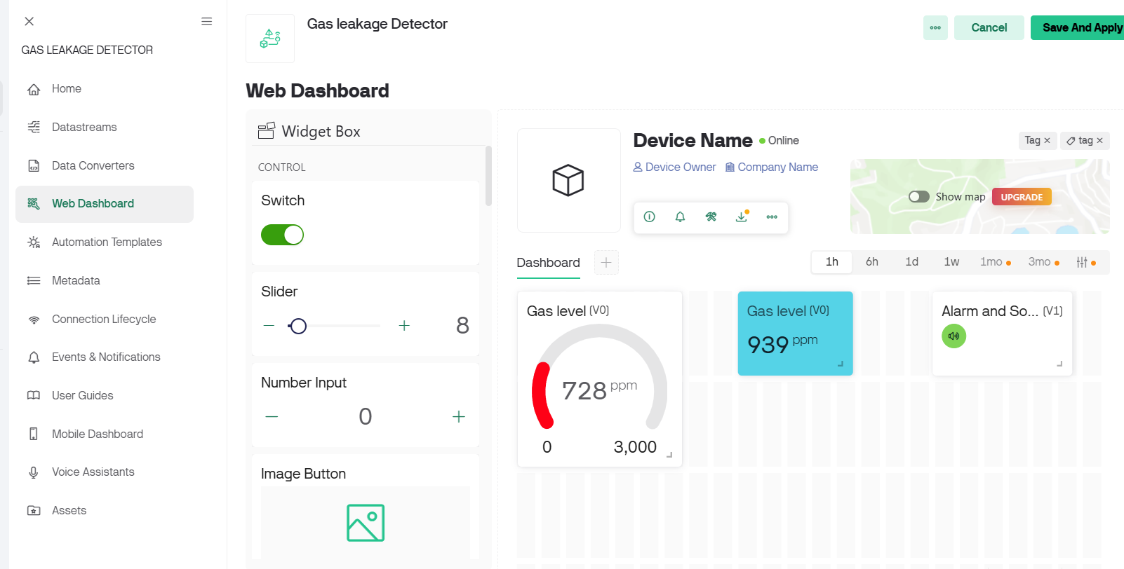
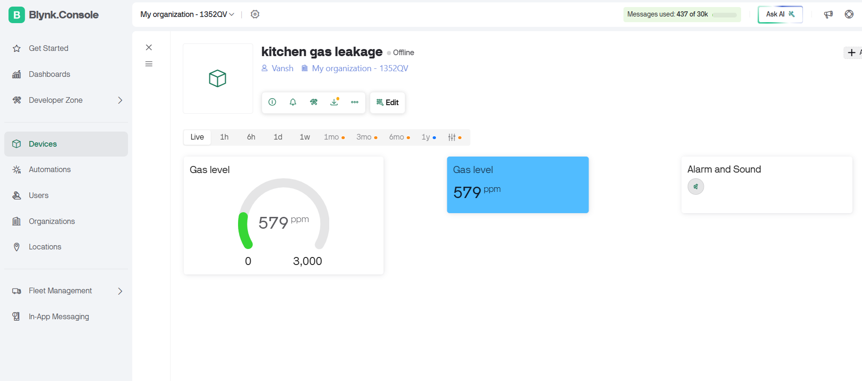

Results and Observations
The system successfully detects gas leakage and responds with both visual and audio alerts. When the gas concentration exceeds 600 ppm, the buzzer and LED activate, the LCD displays a warning, and the Blynk dashboard updates instantly. The Wi-Fi connectivity through ESP32 ensures seamless real-time communication with the Blynk cloud.

Future Enhancements
1. Integration with voice assistants (like Alexa or Google Assistant) for spoken alerts.
2. Addition of multiple sensors for multi-room monitoring.
3. Automatic control of ventilation systems when a leak is detected.
4. SMS or email alerts using third-party APIs.
5. Power backup and offline data logging in case of internet failure.

Conclusion
The IoT-based Gas Leakage Detection System using ESP32 and Blynk successfully achieves its goal of early detection and notification of hazardous gas leaks. The project demonstrates the potential of IoT in home automation and safety monitoring systems, offering both local and remote alerts to ensure user safety.

LINKS: https://wokwi.com/projects/444636068732820481

